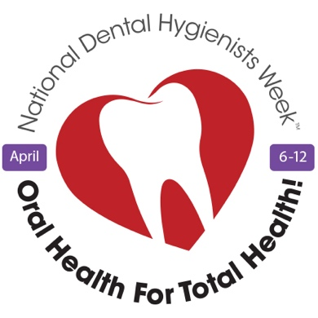
To whom it may concern:
We are writing to request that the municipal landmark________________________ in the community of _________________________ be lit in purple to celebrate National Dental Hygienists Week™ as part of the Canadian Dental Hygienists Association’s national “Put Your Purple On!” campaign.

National Dental Hygienists Week™ (NDHW™) is celebrated annually in the second week of April, highlighting the importance of maintaining good oral health practices while helping Canadians to understand the vital role that dental hygienists play in the health care system. This year, NDHW™ runs from April 6 to 12, and the week's theme is "Oral Health for Total Health," reminding us that taking care of our mouth, teeth, and gums positively impacts other aspects of our lives.

Why purple? The colour purple is associated with dental hygiene, and has been the official colour of dental professionals since 1897 when lilac was first chosen for the emblem of the National Association of Dental Faculties. Purple has long been the trim colour for dental hygiene graduates' caps and gowns and is said to signify compassion, purpose, and inspiration.

Last year, sixteen Canadian landmarks, including the Vancouver Olympic Cauldron, BC Place Stadium, Calgary Tower, CN Tower, Edmonton High-Level Bridge, RBC Convention Centre (Winnipeg), Peace Bridge (Fort Erie/Buffalo), and the Pelham Arches, were lit in purple. We’d like to give every community nationwide an opportunity to share in our NDHW™ celebrations. Please let us know if you are interested in joining our “Put Your Purple On!” campaign this April. You may contact me at_______________________________.
Serving the profession since 1963, CDHA is the collective national voice of more than 29,500 registered dental hygienists working in Canada, directly representing 19,000 individual members including dental hygienists and students. Dental hygiene is the sixth largest registered health profession in Canada with professionals working in a variety of settings, including independent dental hygiene practice, with people of all ages, addressing issues related to oral health. To learn more about your oral health, visit www.dentalhygienecanada.ca.

Regards,

