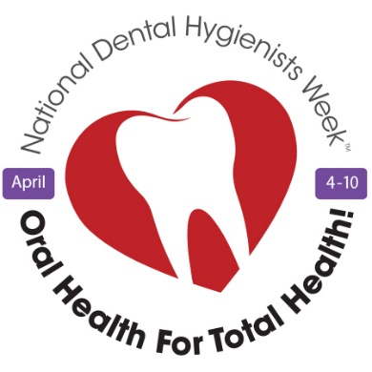
To whom it may concern:
We are writing to request that the municipal landmark________________________ in the community of _________________________ be lit in purple to celebrate National Dental Hygienists Week™ as part of the Canadian Dental Hygienists Association’s national “Put Your Purple On!” campaign.
National Dental Hygienists Week™ (NDHW™) is celebrated annually April 4-10, highlighting the importance of maintaining good oral health practices while helping Canadians to understand the vital role that dental hygienists play in the health care system. Our theme "Oral Health for Total Health," reminds us that taking care of our mouth, teeth, and gums positively impacts other aspects of our lives.
Why purple? The colour purple is associated with dental hygiene, and has been the official colour of dental professionals since 1897 when lilac was first chosen for the emblem of the National Association of Dental Faculties. Purple has long been the trim colour for dental hygiene graduates' caps and gowns and is said to signify compassion, purpose, and inspiration.
Last year, there were 20 Canadian landmarks lit in purple, including BC Place Stadium,
Science World/TELUS World of Science Vancouver, Vancouver Olympic Cauldron & district markers, Victoria Street Bridge, Fort St. John City Hall, Columbia Ave. Overpass Bridge (Castlegar, Calgary Tower, Reconciliation (Langevin) Bridge (Calgary)
Edmonton High-Level Bridge, WINNIPEG sign at The Forks, Niagara Falls, 3D Toronto sign Nathan Philips Square, Peace Bridge (Fort Erie/Buffalo), Brampton City Hall Clock Tower, Welland Bridge, CN Tower, Halifax Convention Centre, St. John’s Convention Centre, Confederation Building (St. John's), Government House (St. John's). Two international landmarks, the Tornado Tower (houses Canadian embassy) in Doha, Qatar, and the M&T Bank (Maryland) were also lit purple.
We’d like to give every community in Canada, and globally, the opportunity to share in our celebrations. Please let us know if you are interested in joining our “Put Your Purple On!” campaign this April. You may contact me at_______________________________________.
CDHA is the collective national voice of more than 29,549 dental hygienists in Canada, directly representing 20,000 individual members, including students. Since 1963, CDHA has worked to advance the profession and promote the importance of oral health. Dental hygiene is the sixth largest registered health profession in Canada with professionals working in a variety of settings, including independent dental hygiene practice, with people of all ages, addressing issues related to oral health. For more information on oral health, visit www.dentalhygienecanada.ca.
Regards,

